RTP Connections on a KP pump.

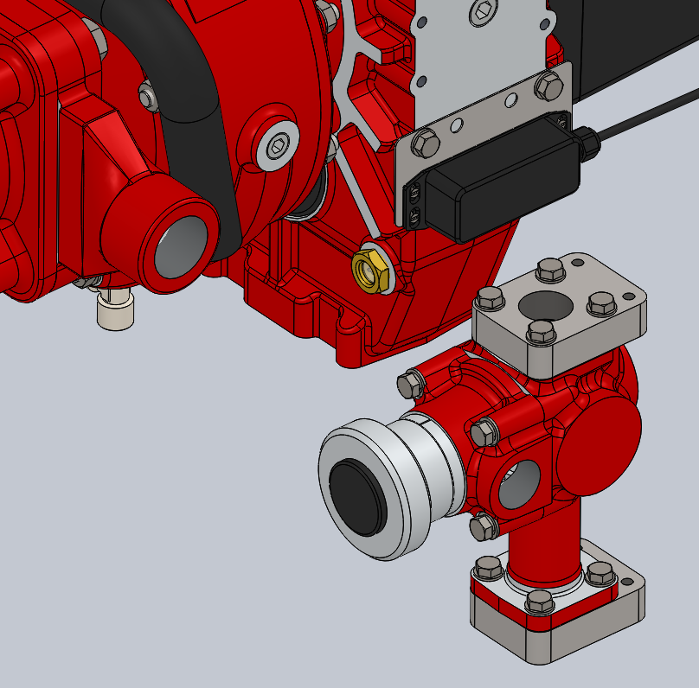
INSERT HOSE FITTING – Rp 1 THREAD.
INSERT HOSE FITTING – Rp 1¼ THREAD.
INSERT HOSE FITTING – Rp 1¼ THREAD.

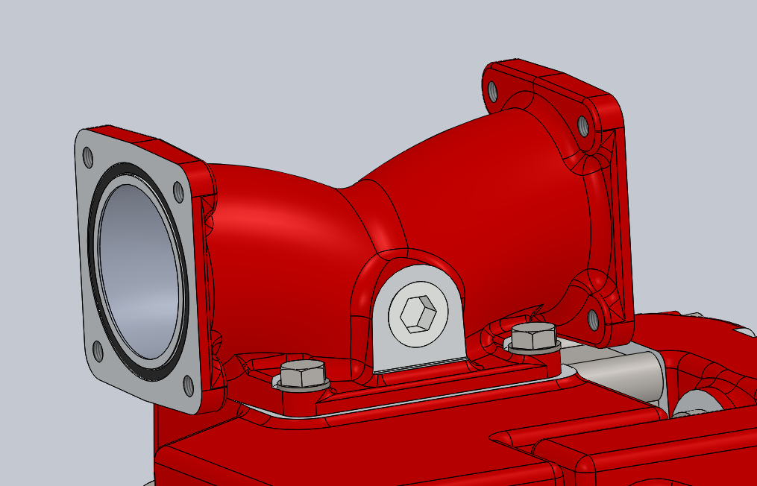
REMOVE PLUG AND INSERT HOSE FITTING. Rp ¾ THREAD IN MANIFOLD.

Use suitable hose/pipework to connect the fittings in the Rp 1¼ hole in the pump and the Rp 1¼ hole in the RTP manifold. Use suitable hose/pipework to connect the fittings in the Rp 1 hole in the RTP manifold and the Rp ¾ hole in the pump manifold. Use as large a bore hose/pipe as possible.

